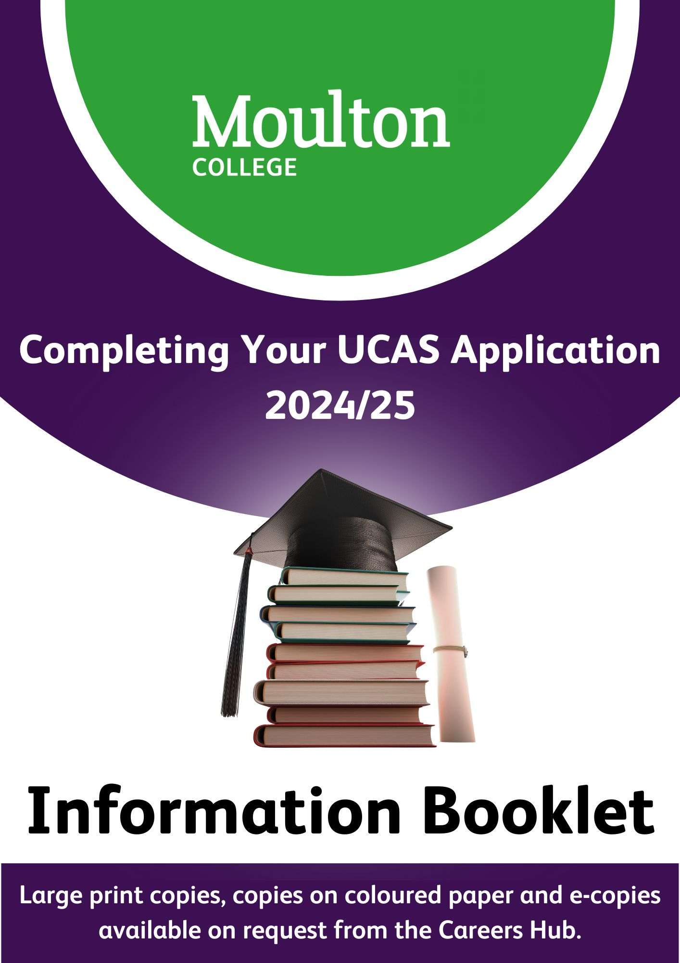

Contents

Key Information

- Summary of key dates
- Submitting an application after the UCAS deadline
- What happens to applications once submitted
- When you have to pay and how much does it cost?

Getting Started - UCAS Hub

- UCAS Hub Registration
- Starting the UCAS Application

UCAS Hub – Application Overview

Completing the application

- Application Page – Overview
- Personal Details
- Contact and Residency Details
- Nationality Details
- Supporting Information
- English Language Skills
- Finance & Funding
- Education
- Employment
- Personal Statement

Adding Choice(s)

Submitting the Application

What Happens Next

Tracking

Who can Help?

KEY INFORMATION

Summary of key dates

Date Event

15 May 2024 UCAS application process for 2025 opens.

3 Sep 2024 Completed applications can be submitted.

9 Oct 2024 Advisory Deadline. Applications for courses at Oxford and
Cambridge, or for most courses in medicine, veterinary medicine/science, and dentistry.

15 Oct 2024 6pm UCAS Deadline. Applications for courses at Oxford and
Cambridge, or for most courses in medicine, veterinary medicine/science, and dentistry.

9 Dec 2024 Advisory Deadline. Submission of all applications to the
Careers team

29 Jan 2025 6pm UCAS Deadline: all applications to be submitted to UCAS.

Submitting an application after the UCAS deadline

Universities and colleges DO NOT have to consider applications received after the deadline, although they can if they have spaces available once the on-time applications have been considered.

What happens to applications once submitted?

It comes to the careers team for checking and reference verification. Therefore, applicants are strongly advised not to submit their application just before a UCAS deadline. If they do so, it may not be checked and submitted on time.

When you have to pay and how much does it cost.

You need to pay when you submit your application. If the careers team return your application to you due to errors when you re-submit you will not have to pay again.

It costs £28.50 to submit an application.

UCAS is removing the application fee for students in receipt of free school meals.

GETTING STARTED – THE UCAS HUB

UCAS Hub Registration

All applications must be completed online. You can do this by following the steps detailed below.

Step 1. Go to www.ucas.com, Select Sign in from the drop-down menu.
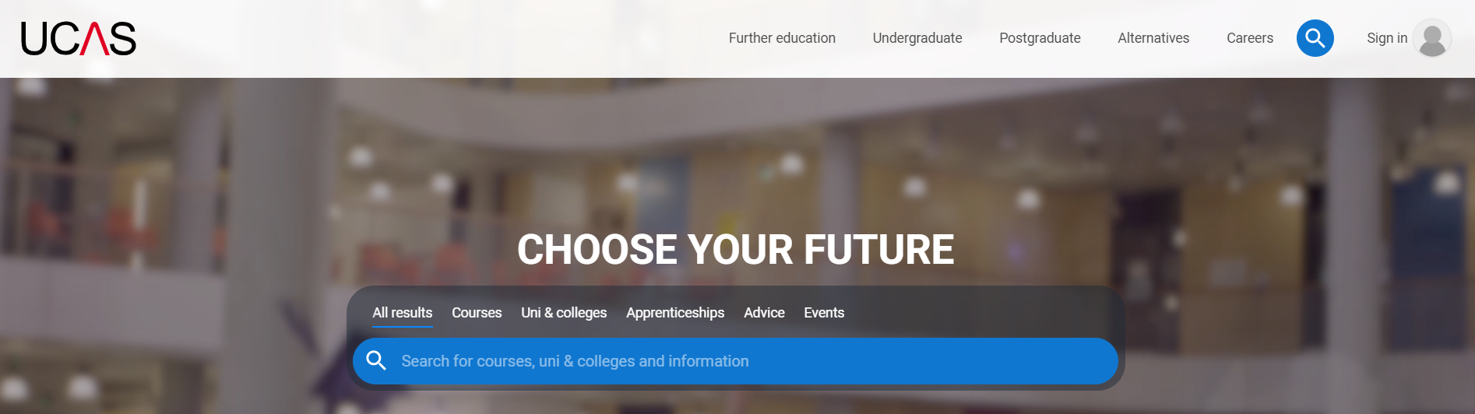

Step 2. Register for an account.

`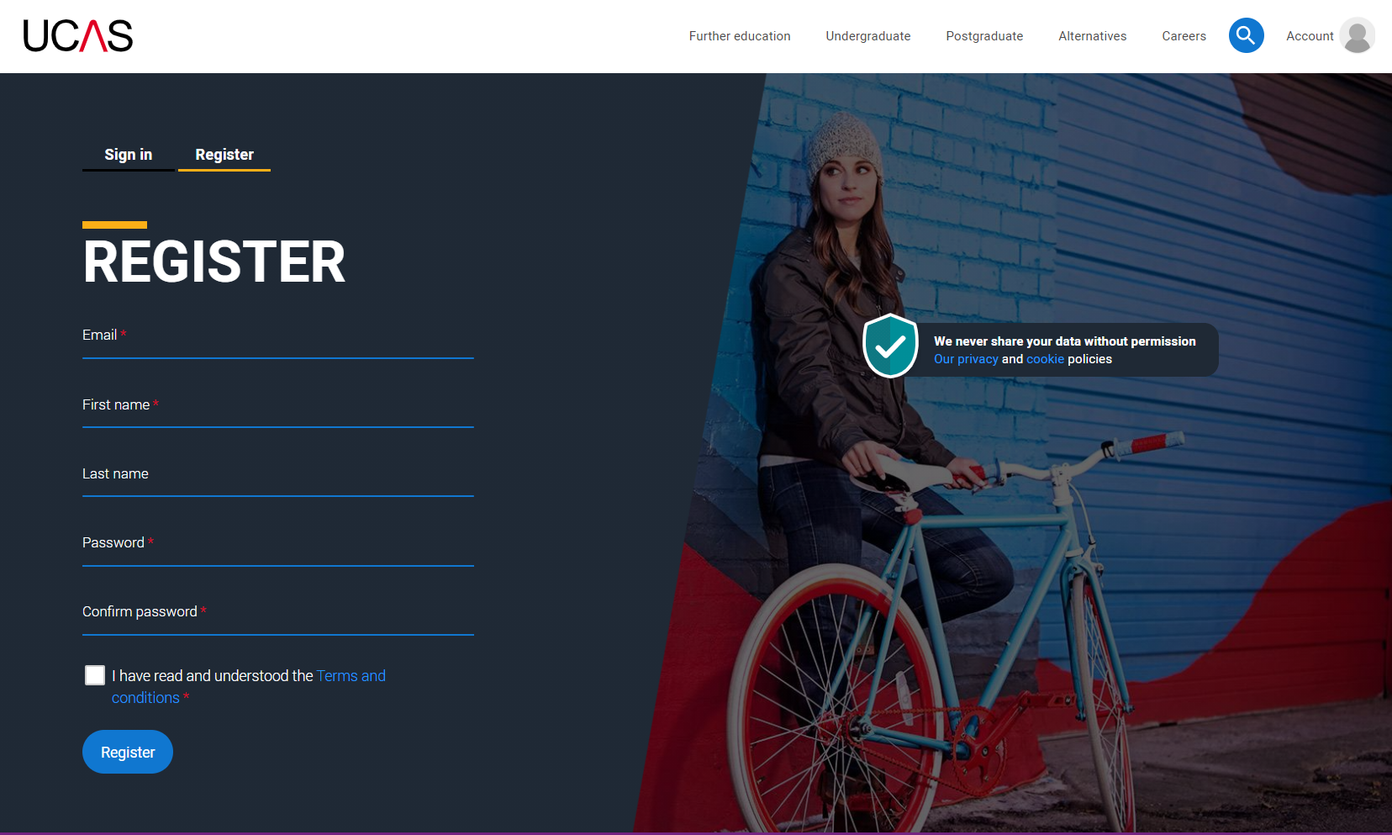

Top Tips:

- Your names must be in initial capitals. For example, Karen Green, not karen green.

- Use a professional email address, such as; kgreen@.......

- DO NOT use your college email address. You will not be able to access college emails once you leave the college in June 2025 and, therefore, universities will not be able to contact you.

- Make a note of your username and password, you will need them to start your application and every time you log in.

Step 3. UCAS will email you a code to verify your email address, so they know they have got your details right.

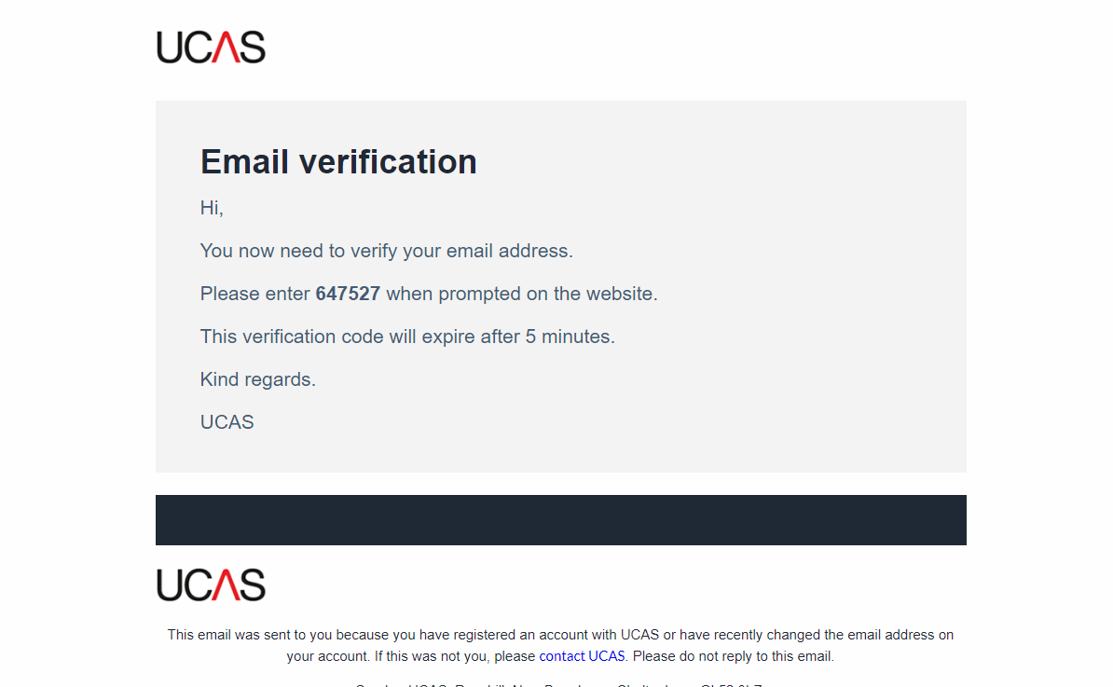
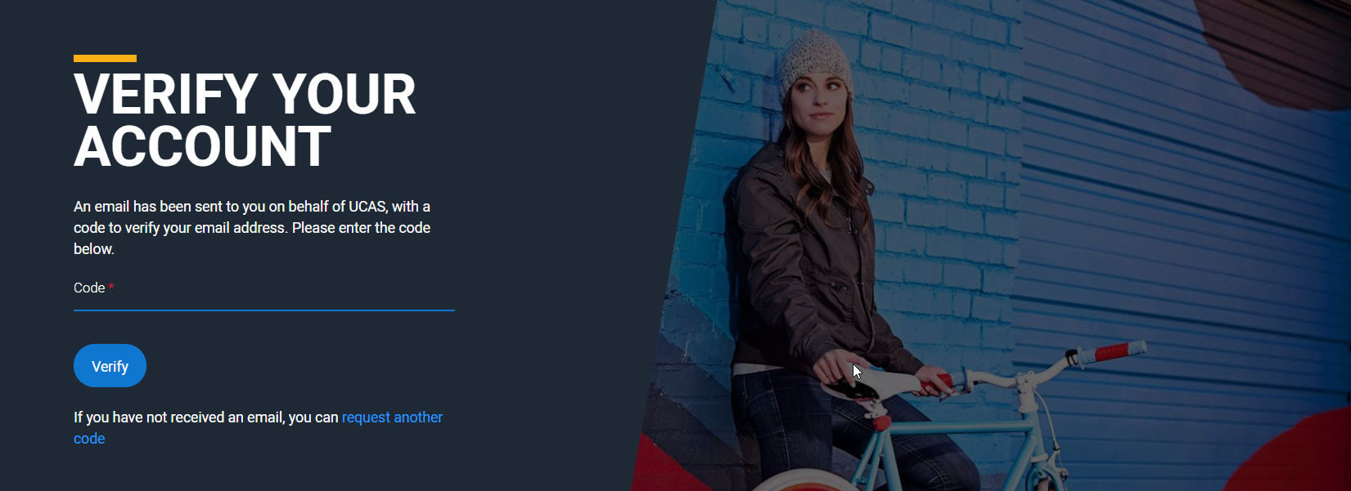

Step 4. Once you have registered you will be asked a few questions, like when you want to start studying at university, where you live and what you are interested in so UCAS can tailor the information you see.

Top Tip: Make sure you choose the correct study year, 2025, if you want to start next year.

Step 5. Choose the correct level of study, it will be Undergraduate. Here you can also choose to get information on apprenticeships and conservatoires.

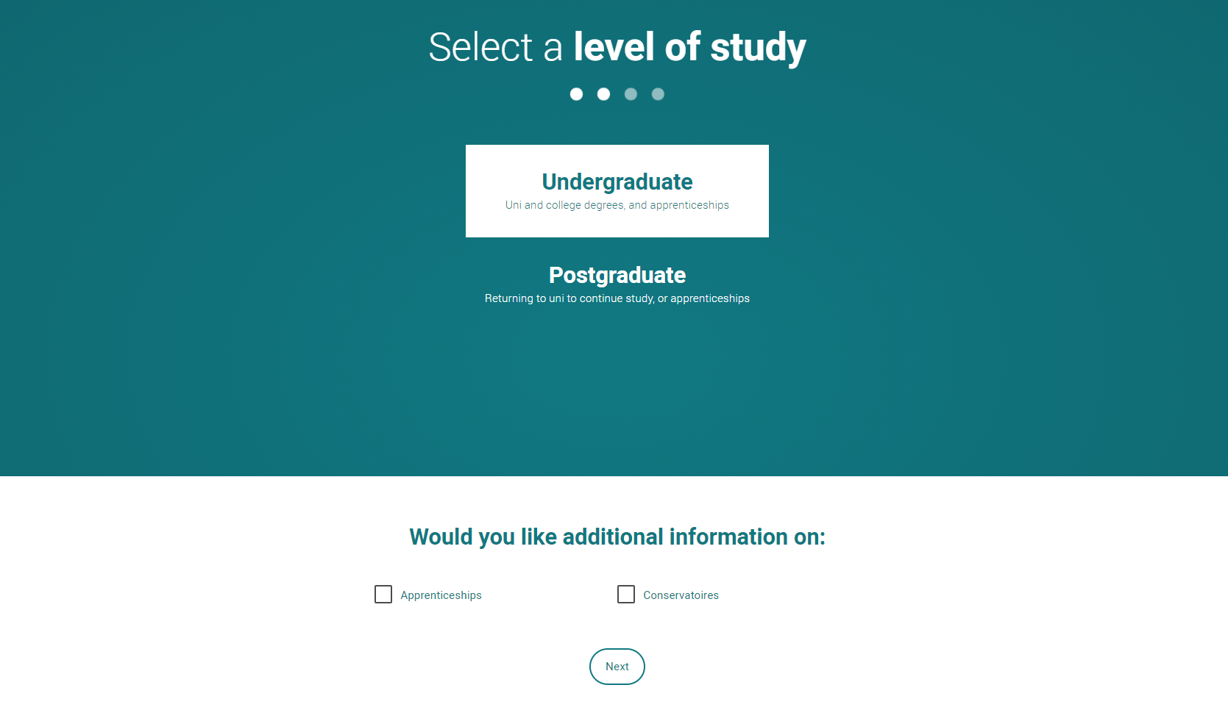

Step 6. Choose if you want to get tailored information about universities, colleges, and apprenticeship options. Also, select the subjects that you are interested in – you can change these at any point in your ‘preferences’. Once you have done this, scroll right to the bottom to Create account.

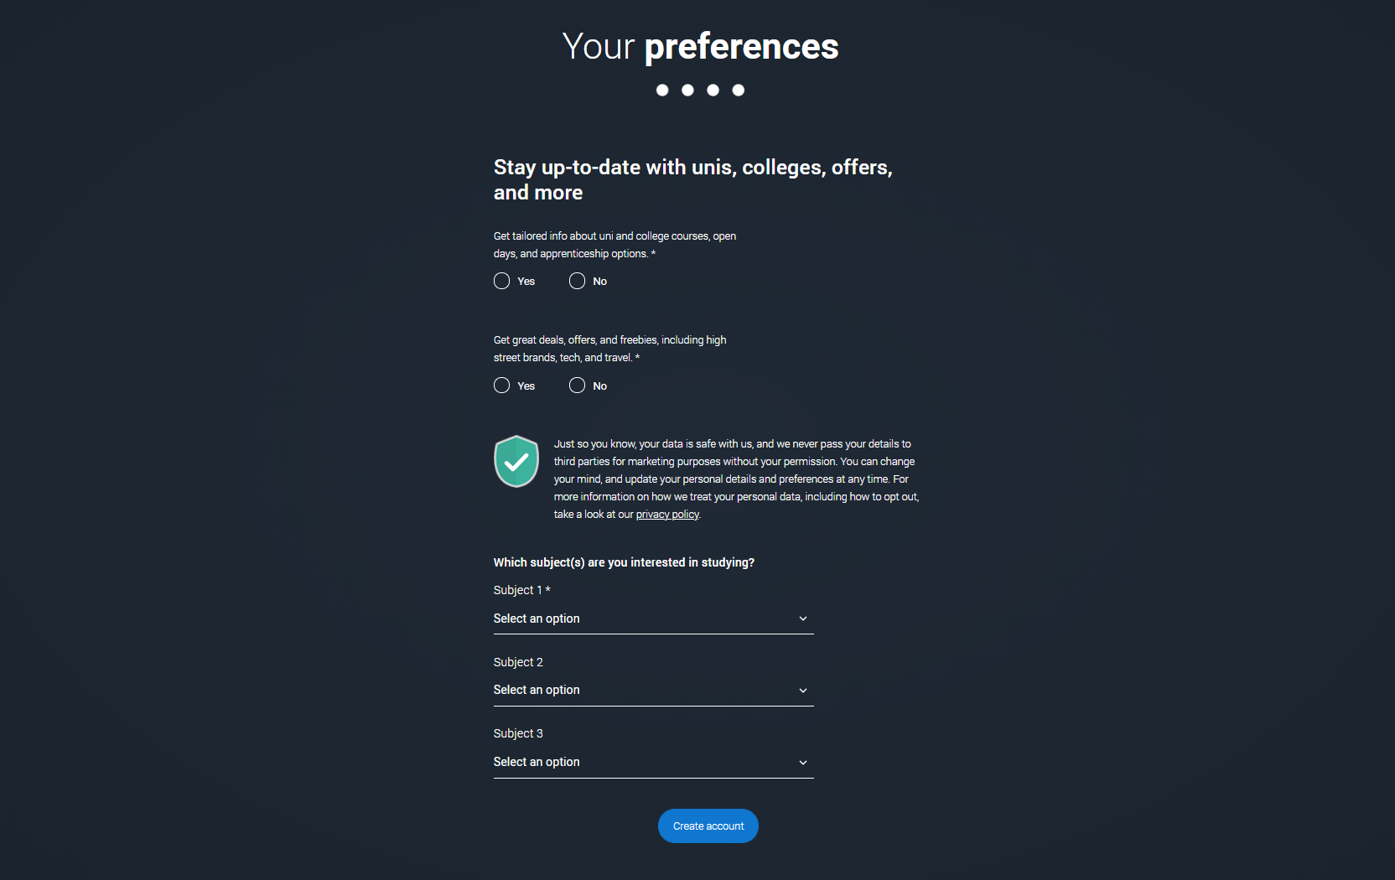

Starting the UCAS application

Step 1. To start your UCAS application, click on the Your application tile.

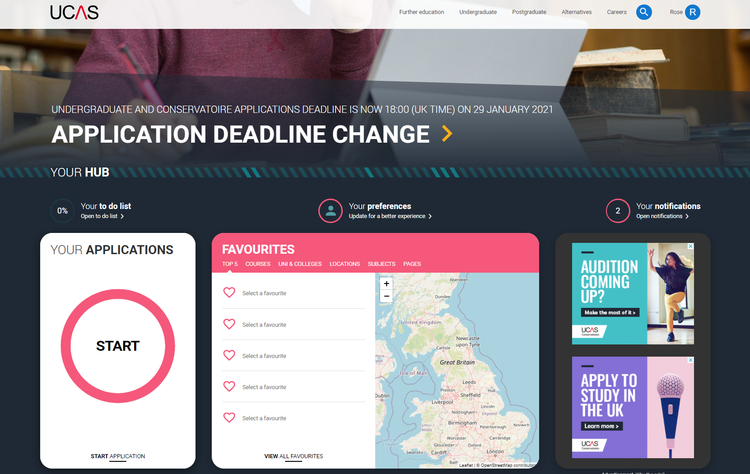

Step 2. Make sure you have the correct year. If you have a Hub account and have previously said you are interested in courses for 2022 cycle you will see this. To start you 2025 UCAS application click on the Your application tile with the red circle:

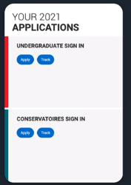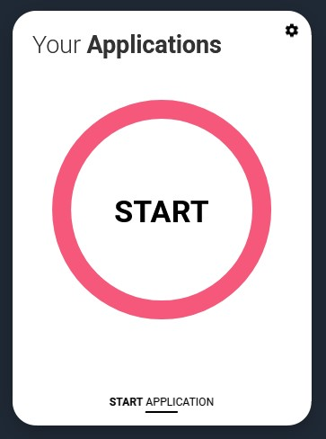

Note. If you need to change your preferences, like the year you want to start your course click here.
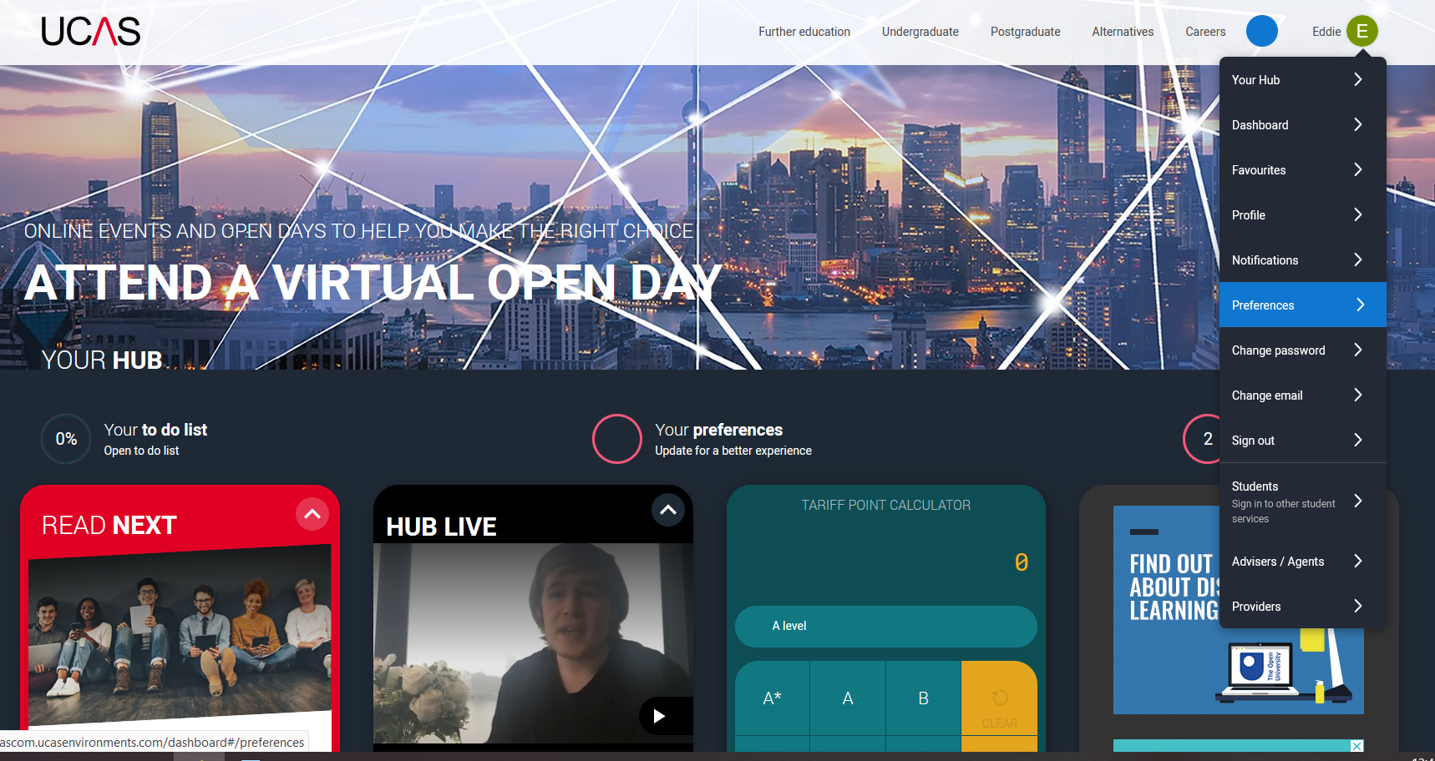

Step 3. You need to link your application to Moulton College. To do this you must first answer ‘Yes’ to ‘Are you applying from a school, college or centre?’.

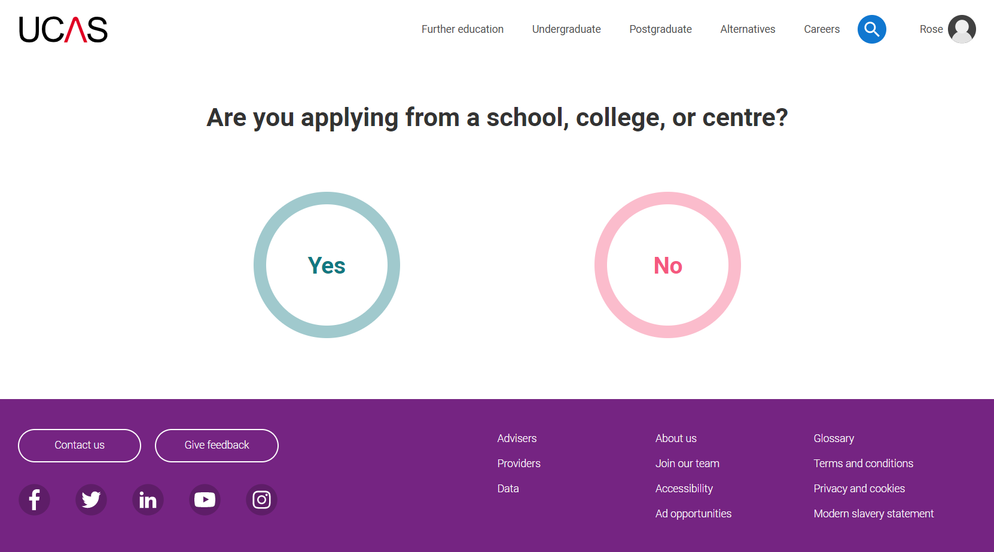

You must then enter the Buzzword. This is Moulton2025

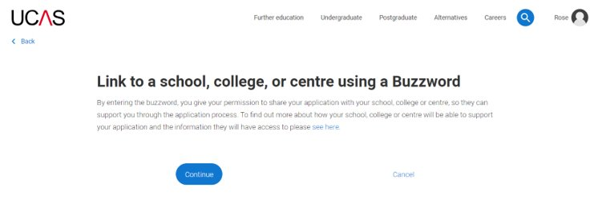
Enter the Buzzword and confirm the details are correct.

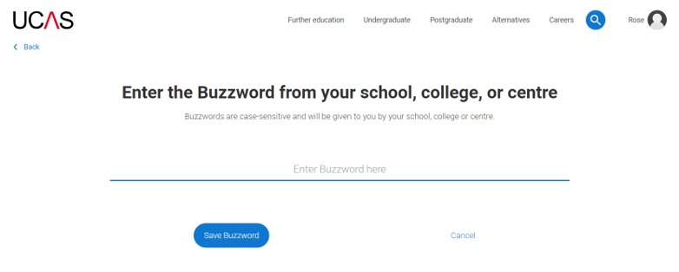

This will link your application to your school or college and enable the careers team and your Personal Development Tutor to track your progress and provide support, including adding your reference.

Once your application has been linked, you can then select a group for your application. This will be the name of your course.

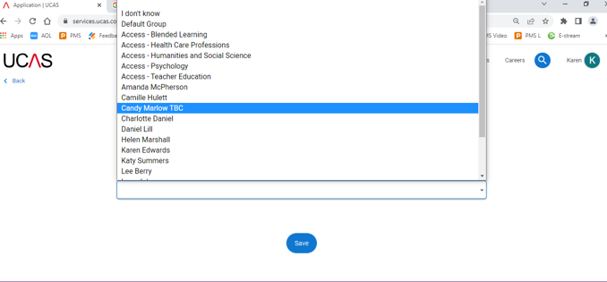

UCAS HUB - APPLICATION OVERVIEW

Your homepage is where you'll see the sections that need completing. You don’t need to complete the application all in one go, you can log in and out at any time until you're finished. As you add information to each ‘tile’ the percentage complete dial should increase each time you mark a section as complete.

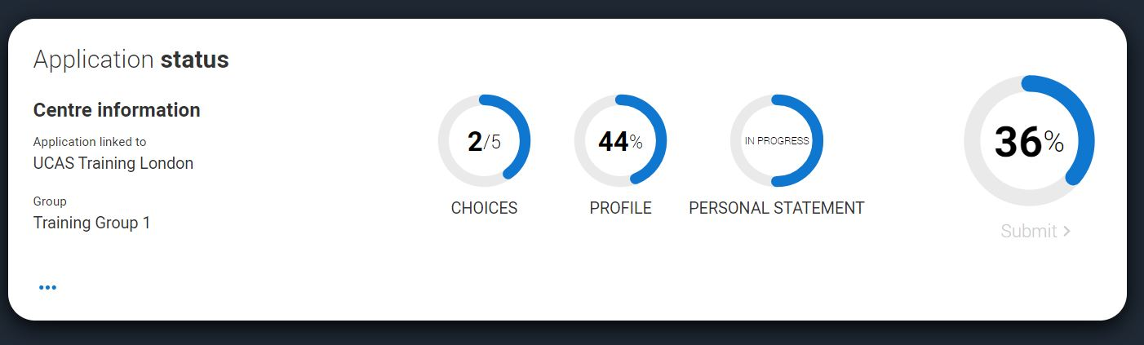

The second part is where you can select your university choice(s). There is also a search facility to help you find courses and providers.

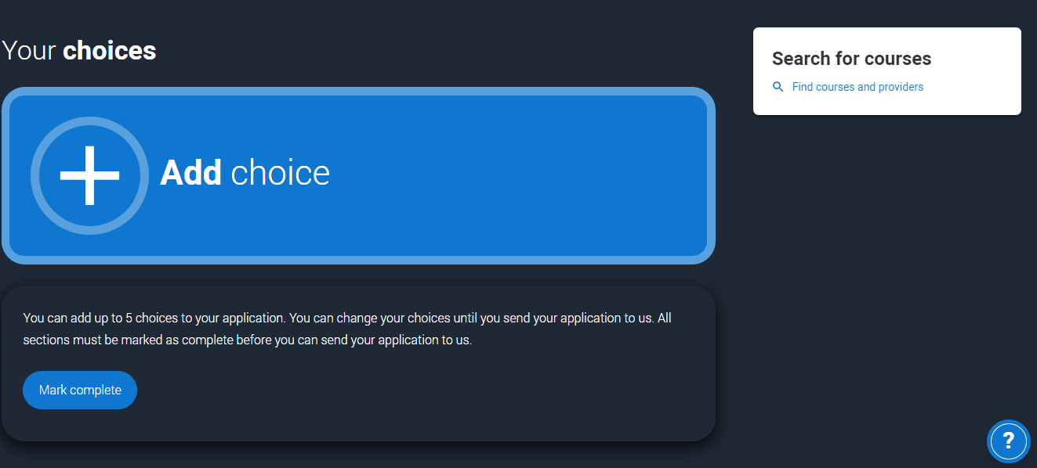

The third section is your profile - information about you. The tiles will give you an overview; if a section is complete, in progress, or you need to start it. All sections must be marked as complete to send to UCAS. You must complete all mandatory questions to mark a section as complete (they have a *).

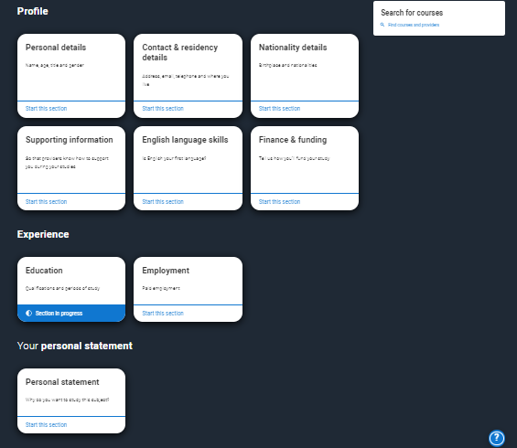

COMPLETING THE APPLICATION
Application Page - Overview

Click on any of the sections and you will see a list on the left showing which sections are completed (with a tick), which are in progress (with a half-moon) and which have yet to be started (no icon).
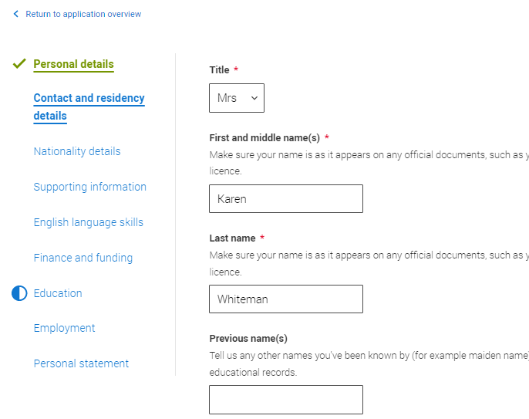
Click on the throughout for help text to provide advice about what to put.

Personal Details

Your name should already be visible, but you'll need to add your title and complete the other mandatory fields (marked with a *). Once you have completed a section you must remember to mark the section as complete at the bottom of each page.

Note: Your names must be in initial capitals. For example, Karen Green, not karen green.

Contact and Residency Details

You should provide either a landline or a mobile number in this section. You'll only see the fields to add the nominated contact details if you answer Yes to the question. This means someone else can speak to UCAS about your application if necessary.

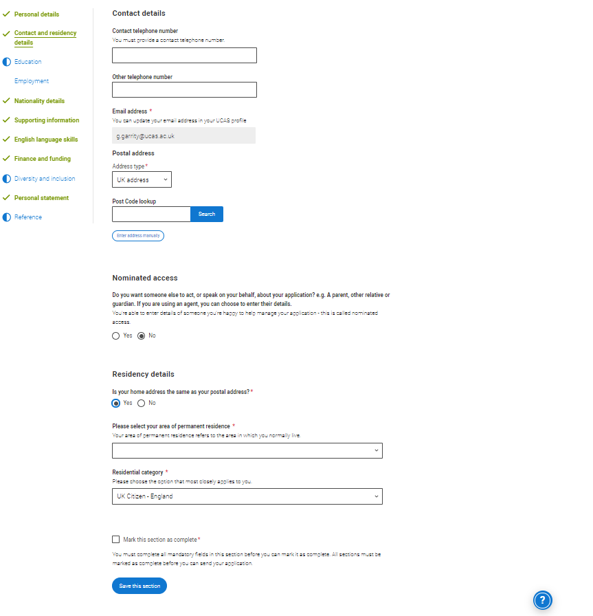
If you select No to ‘Is your home address the same as your postal address?’ then another box will appear and you will be required to confirm your home address.

Nationality Details

The information you provide will help universities and colleges in determining your eligibility and allow them to assist you with the visa application process, if required.
If you are a UK national, this is what you will see.
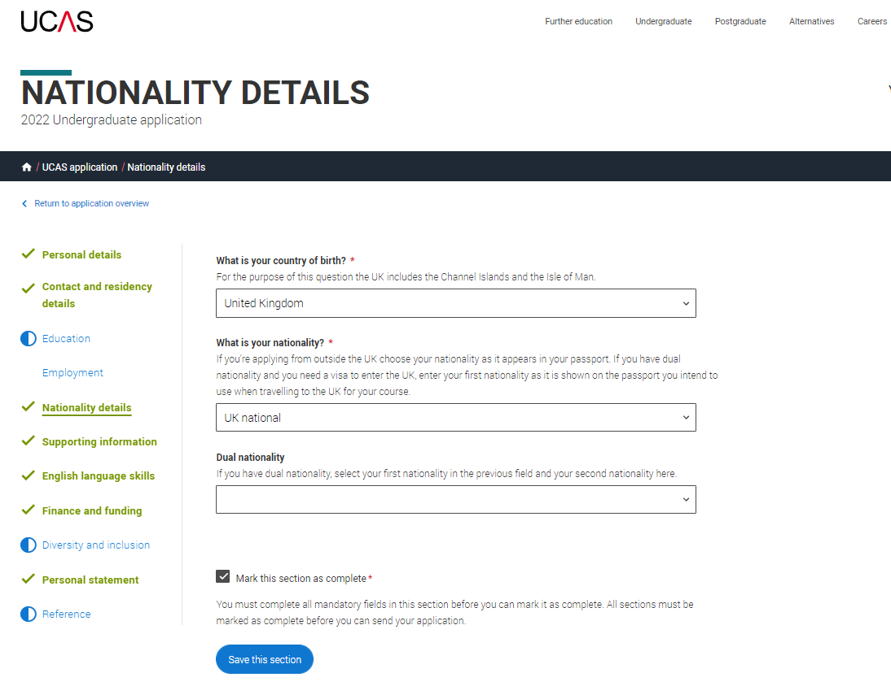
Born in UK but have a different nationality. You will be asked additional questions. The information you provide will help universities and colleges in determining your eligibility and allow them to assist you with the visa application process, if required. There are some possible combinations but your form will only show relevant fields depending on your answers.

Not born in the UK? If you weren't born in the UK you’re asked for the date of first entry to the UK. If you’re not in the UK yet, put the first of the month you plan to arrive. There are some possible combinations but to help you we'll only show relevant fields depending on your answers.

Supporting Information

Complete as appropriate.

English Language Skills

If English isn't your first or primary language, the form will ask for your TOEFL or IELTS registration numbers, you only need to enter reference numbers if you’ve been assigned one and you know it.

Finance and Funding

If you are applying for a Student Loan to cover your university costs then you should select the following from the drop-down menu:

UK, ChI, IoM or EU Student Finance Services

If you select the above you will be asked to select your home county from the drop-down menu. This would normally be Northamptonshire.

Education

You need to add details of all the qualifications you’ve already achieved and those you’re studying towards.

- First you need to add details of where you’ve studied, or are studying, then add qualifications – this must include your GCSEs / Level 2 qualifications. Start by clicking Add place of education.

- You’ll be asked for a Unique Learner Number. You can get this from Proportal or your Personal Development Tutor, Tutor or from the careers team.
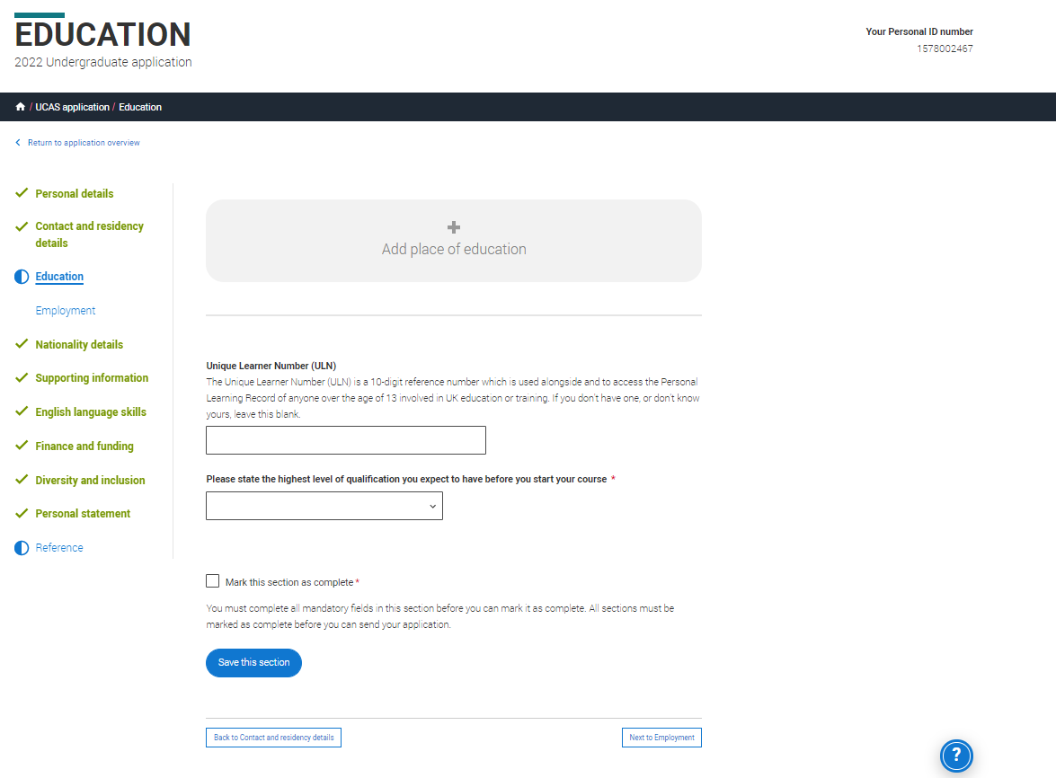
Add place of Education

- Type the name of where you studied. Once you find your centre, click on the name and the Exam centre number will automatically populate.

- If an exam centre number doesn’t appear that’s ok, it’s because we don’t have it.

- Add when you started and finished, and if you’re still studying there add the month, you’re due to finish.

IMPORTANT. For place of current study select Moulton College.

Warning Messages. There are warning messages to help you. For example, you can't say you attended 2 or more places of study full-time during the same date range. Red text are warnings and mean something is wrong and blue text is for information you need to be aware of.

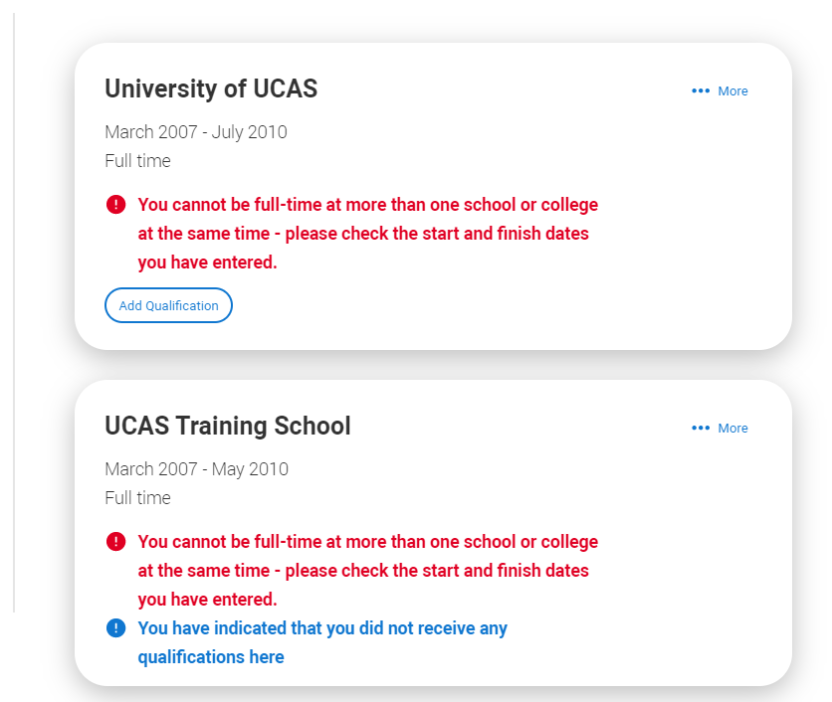

Once you’ve added where you studied you can enter the qualifications. Click the Add qualification button and search for your qualification.

IMPORTANT:

- For your current studies, please check what detail you need to add with your, Personal Development Tutor or The Careers Team.

- The qualification dates you can select are based on those you entered when you set up the centre.

- If you know which awarding organisation it is, enter it here – speak to your Tutor or Personal Development Tutor if you’re not sure.

- If you haven't finished the qualification or had your result, then you must choose Pending.

Employment

This section is for PAID work only.
Do not include your Work Experience or any voluntary work.

If you add more than one employment it will appear in chronological order with the most recent at the top. Not everyone will have something to enter here - but remember to mark the section as complete!

Note: You must use initial capitals for employer names and addresses. For example, Tescos, not tescos and Church Street not church street.

Personal Statement

You can save and edit this section as many times as you need to. If you try to navigate away without saving your work. We'll remind you with a pop-up warning.

The Mark this section as complete feature is only available on the Preview screen.

Note. Please refer to separate leaflet for guidance on how to write your Personal Statement.

ADDING CHOICE(S)

This is where you select your choice(s) of courses/university(ies)/college(s). To add your choices, click the Add choice section, found on the main UCAS Application page.

- Start typing the name of the university or college into the institution field. Select from the options displayed.
- Do the same for the course you have selected.
- Locations and start dates are displayed according to the course details.

Criminal convictions. Some courses may require you to disclose your criminal conviction status. You will need to select ‘Yes’ or ‘No’.

Note: The form will only show this question if the course choice requires it.

There is a maximum of 5 choices and choice restrictions still apply (a maximum of four courses in any one of medicine, dentistry, veterinary medicine or veterinary science).

Once all choices are added select confirm choices to mark the section as complete.

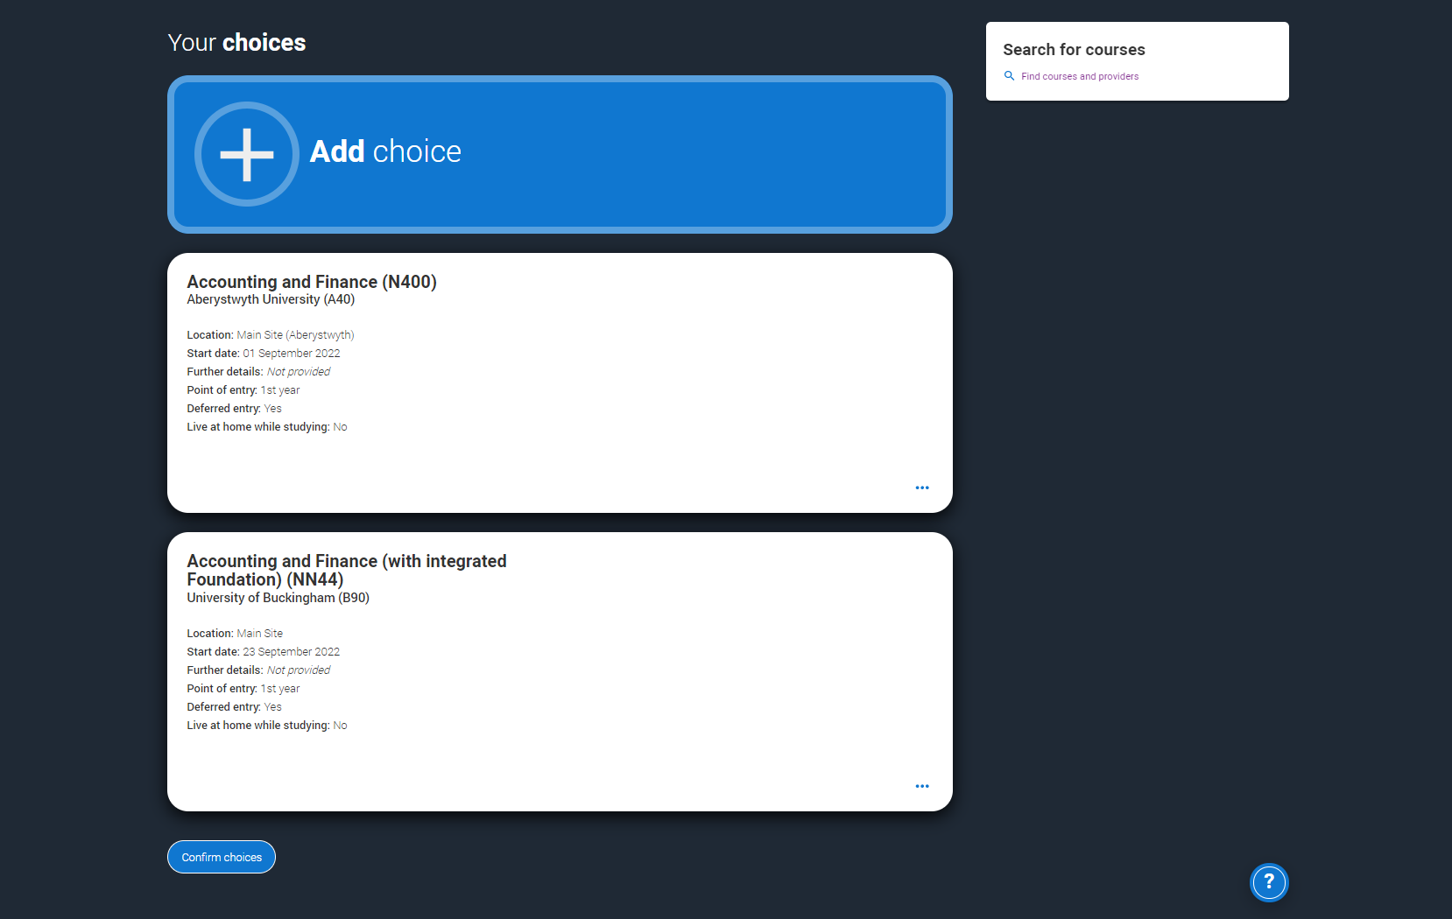

Some courses have extra admissions tests and assessments. The form will show these in blue text on the choice card. This should not be a surprise to you, as you should have seen details of this when researching the course.

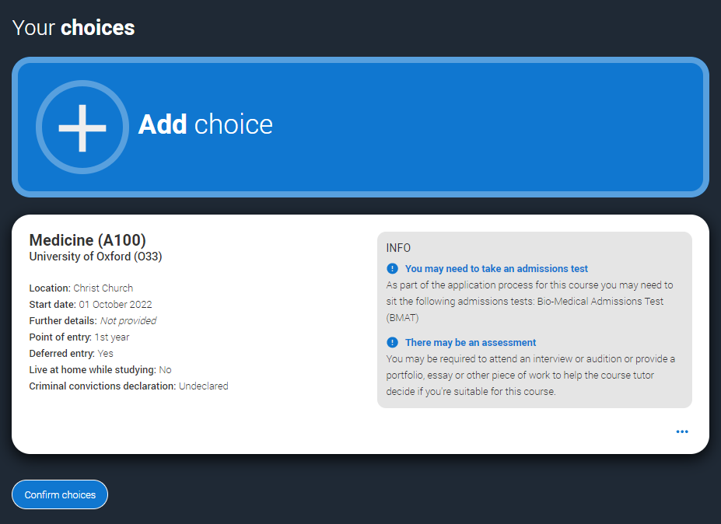

Clicking the 3 dots in the bottom right of a card enables you to see it as a summary.
Any choice combinations that are not permitted will be flagged with red text on the right of each relevant card.

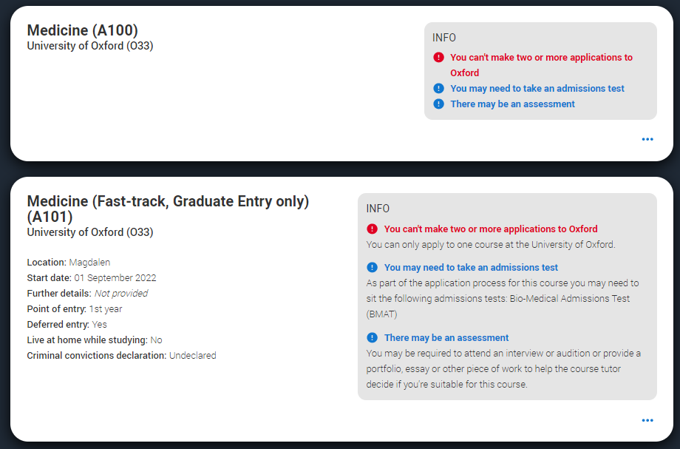

For example, these screens show error messages for students trying to apply to University of Cambridge and University of Oxford.

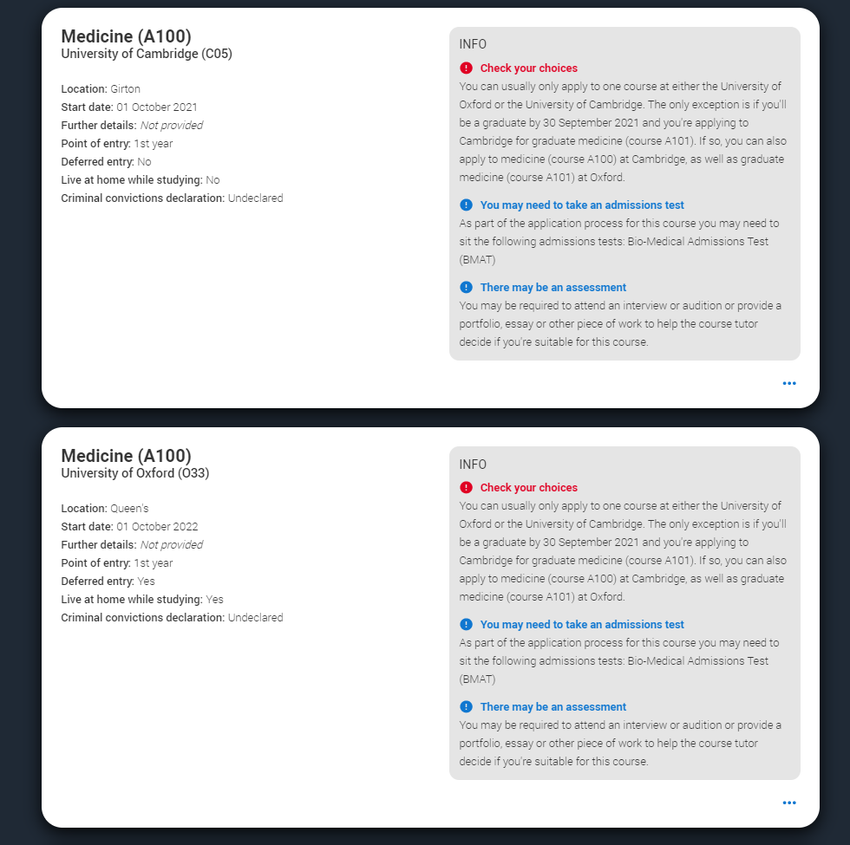

SUBMITTING THE APPLICATION

There are 4 steps to the submission process. The application must be complete (showing 100%) before pressing submit.

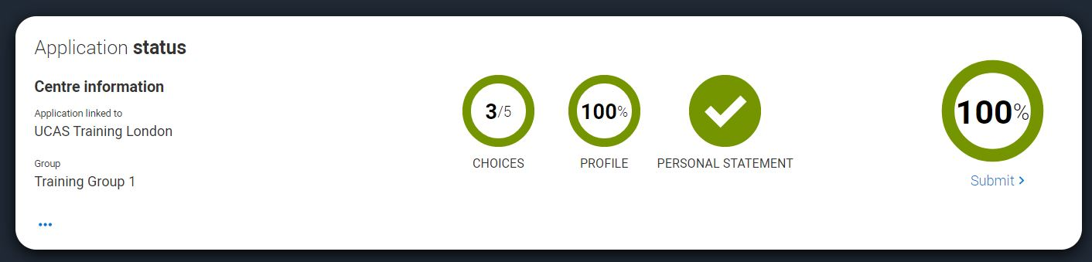
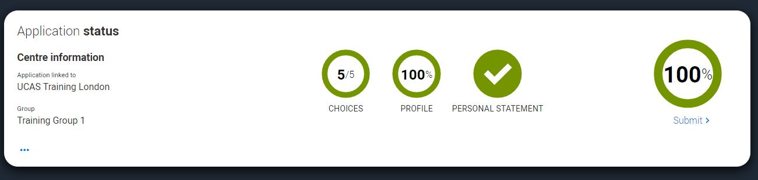

This shows the full application and you can download it as a pdf (in the top right) to help you check it.

At the bottom of the application, click Accept and proceed (or return to application if you want to make more changes).
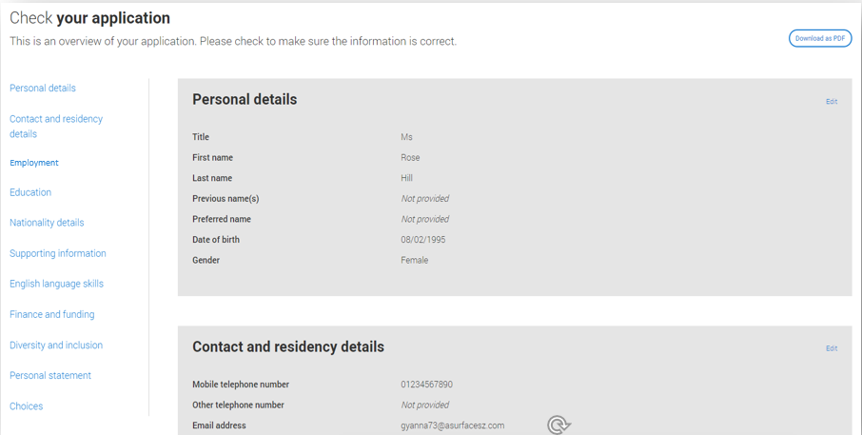

The form will then need you to update your preferences.
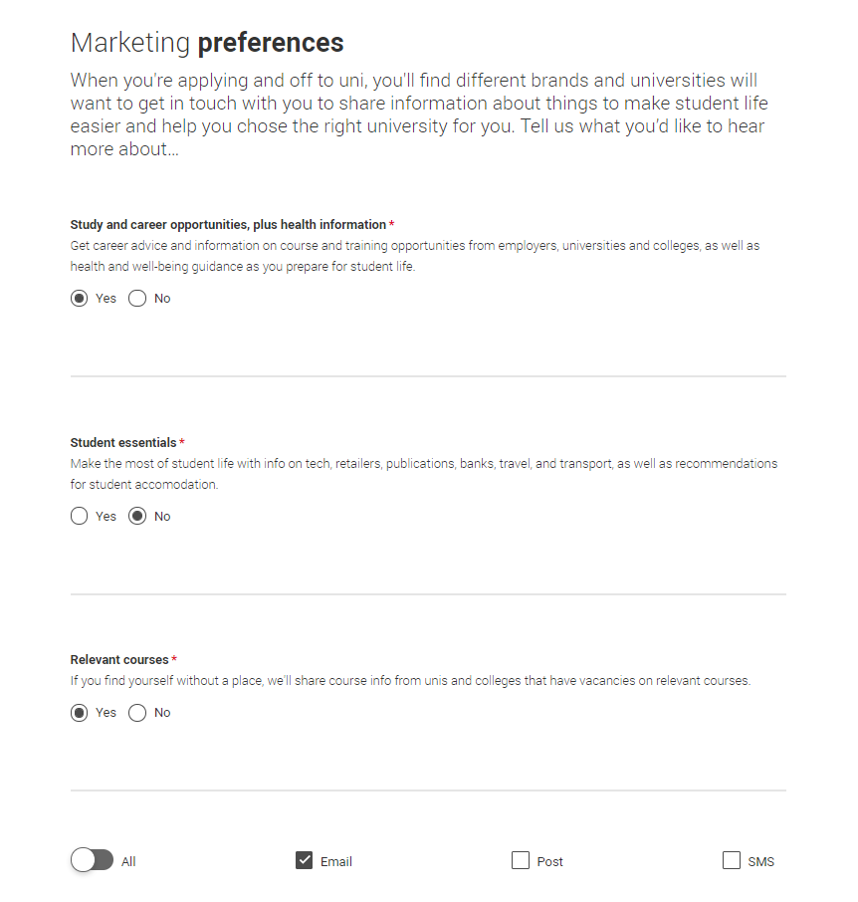
You must tick the box at the bottom of the page to confirm you have read and understood the terms and conditions.

You can collapse these by clicking the

Then click Accept and proceed, or you can ‘Return to application’, or ‘Return to marketing preferences’.

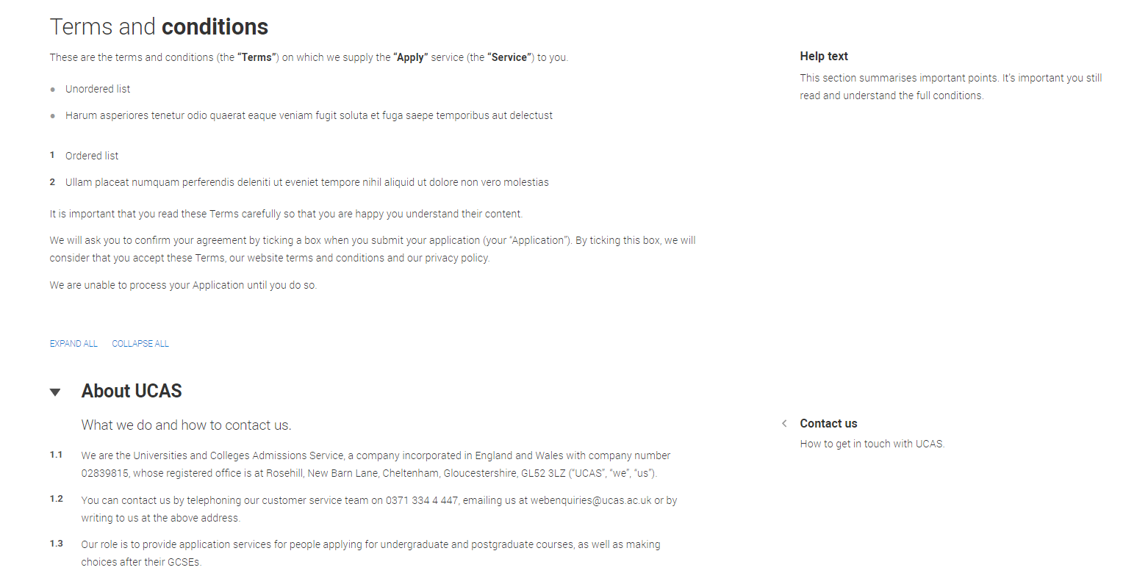
The fee for applications is £28.50, no matter how many choices you make.

Payments for your choice(s) has to be made at the point of you submitting your application and can be made through Credit or Debit Card.

WHAT HAPPENS NEXT

When you've paid and submitted your application, it will go to your careers team for checking.

- Application correct. The careers team will check your reference is attached and then email you and ask you to confirm that you are happy for them to submit your application to UCAS. On receipt of this confirmation the careers team will submit that application to UCAS.

- Errors on application. The careers team will release your application back to you. They will also email you and provide details of what requires amending. You will not have to pay again when you re-submit.

Notes:

- Once you have submitted, you will only have a read only version. Should you need to make any changes you will need to email: careers.team@moulton.ac.uk and ask them to return your application to you.

- Once your application has been submitted to UCAS, by the careers team, you will no longer be able to amend your application. Any changes will have to be made via UCAS by contacting them, ensuring you have your UCAS reference number at hand.

TRACKING

You can track your application online, via UCAS Track. Once the careers team have submitted your application to UCAS you will be emailed a leaflet which provides details on tracking. You can track your application from the moment it is sent to UCAS.

WHO CAN HELP?

If you would like help with your UCAS application, or Personal Statement, please speak to your Personal Development Tutor in the first instance. Additionally, you can contact the careers team on 01604 491131 or email careers.team@moulton.ac.uk to book an appointment.

